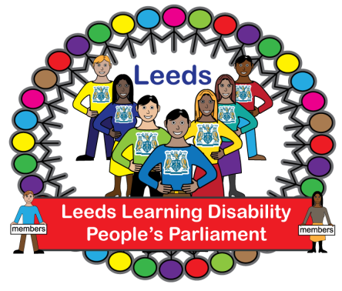** Agenda for People’s Parliament**

**Tuesday 28th November 2023**

**10.00 Arrival – Name Badges – Tea and coffee.**

**10.20 Welcome from Em Pearson (Chair) Icebreaker: What does Being Safe mean to you?**

**10:30 – Presentation about Being Safe: Imogen Day and Kenneth Fletcher**

**10.40 Being Safe – discussion**

**11:20 – Nicky Lines to tell us about online banking survey**

**11:25 Leeds Safeguarding Adults Board video - Susan Hanley**

**11.30 Break**

**11.45 Sergeant Richard Cotton – Safer on Buses**

**12:30 Lunch**



