Walking Journey from
Leeds Bus station to Pop World
5:45pm on Thursday 18th June
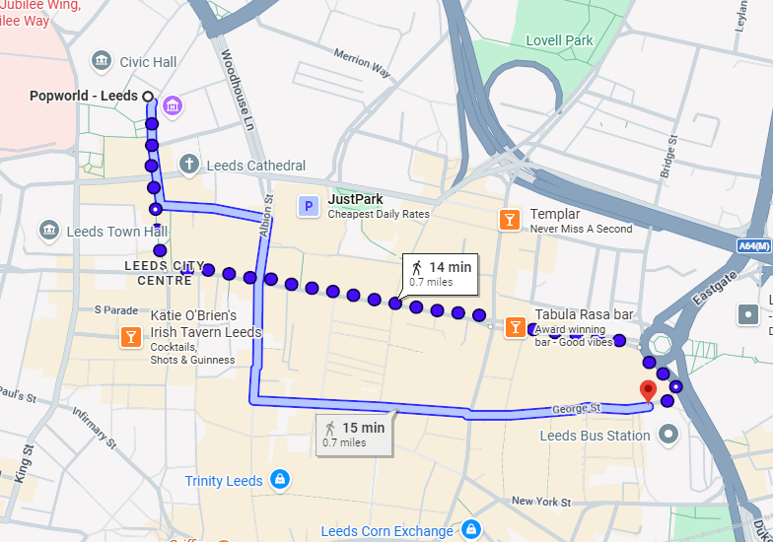
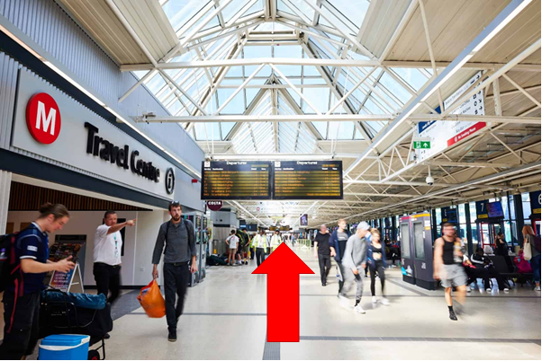
If the travel centre on your left head straight until you reach the exit!
If not turn left from the stand you were at and continue straight to the exit!
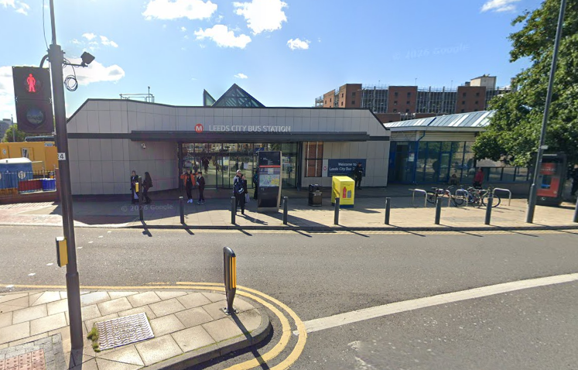
(THIS IS THE MEETING POINT! – wait for the group HERE)
At the exit turn right and head to the crossing.

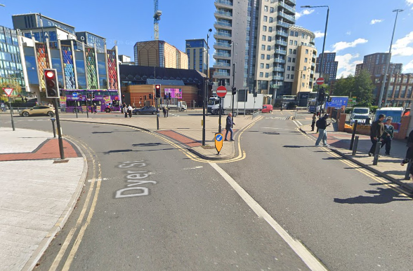
Use the Two crossings here that are to your right to cross the road when green man shows.
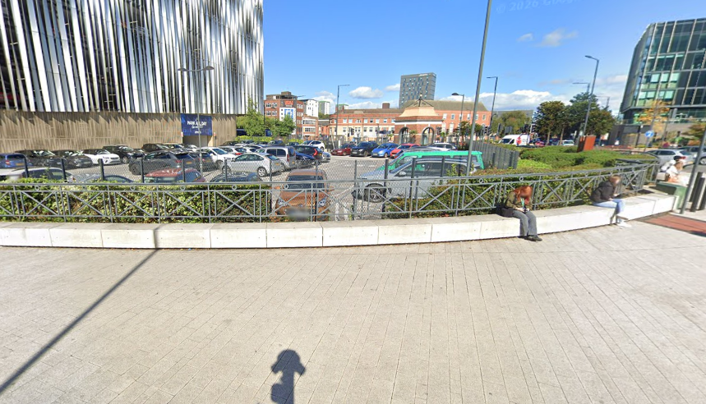
and then turn right and head towards the Eastgate Roundabout

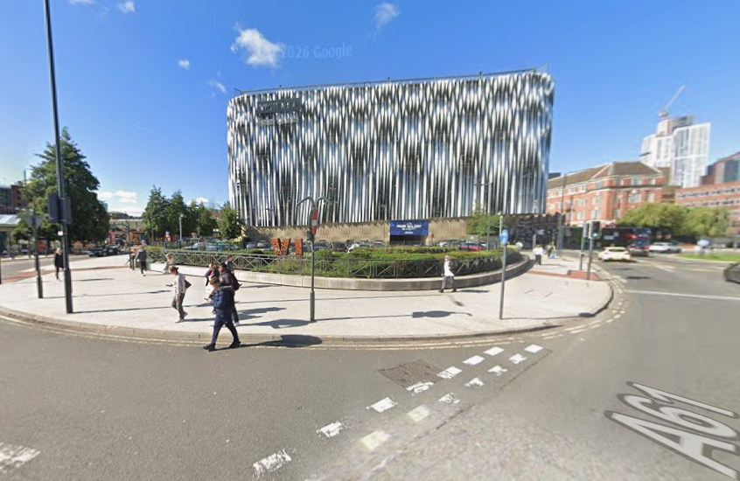
Continue around the corner
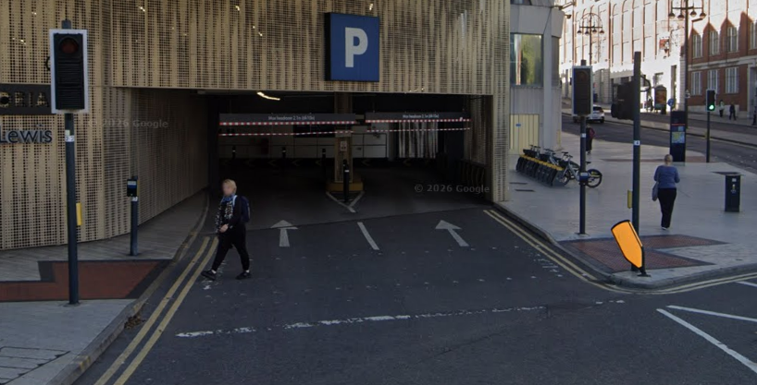
Once you reach the roundabout, use this crossing to cross over the entrance to the Victoria gate carpark. Wait for the green man.

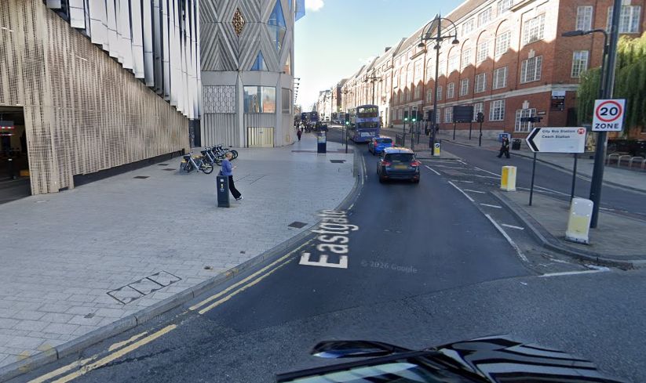
Turn left onto Eastgate and continue forward up to The Headrow.
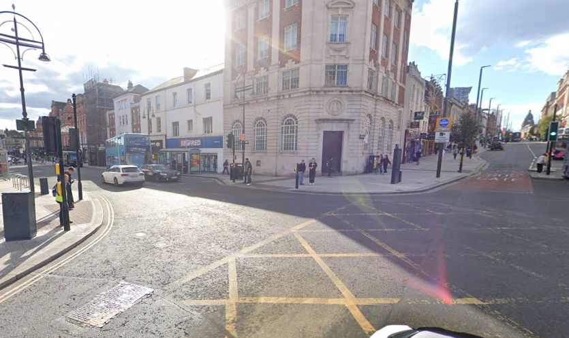
When you reach the junction with Vicar Lane use this crossing to continue straight over to onto The Headrow. Wait for the green man.

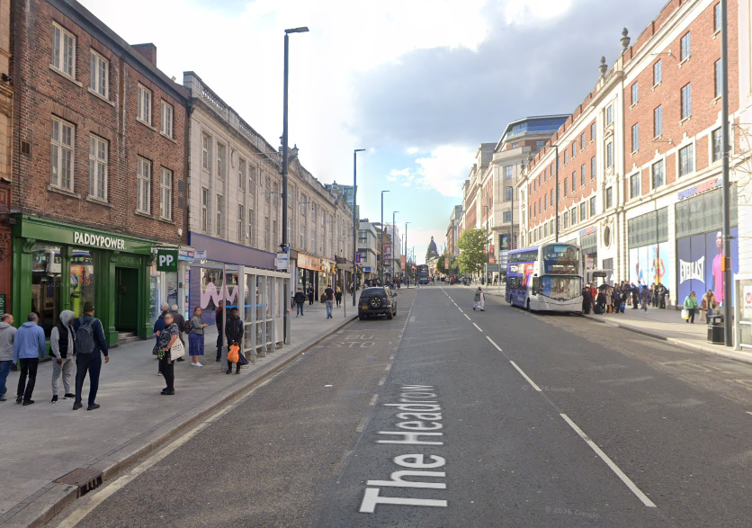
Continue up The Headrow until you reach Albion Street. When you get there, you should see Currys on your left and Leeds mathematics school ahead.
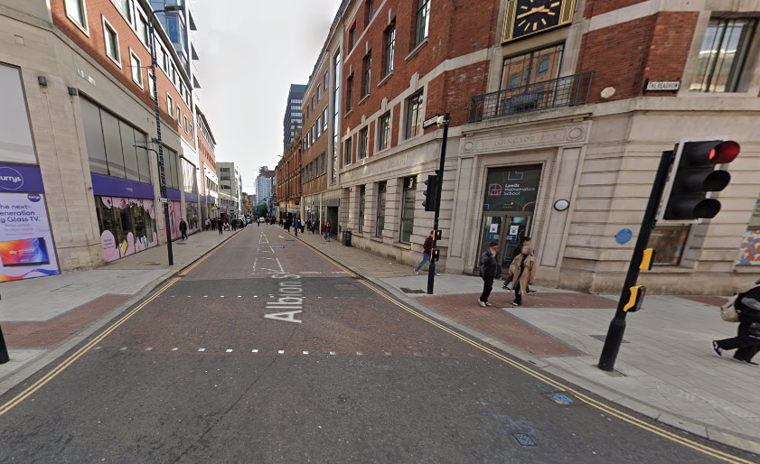
Once you arrive at the junction use this crossing to continue over Albion Street to stay on The Headrow. Wait for the green man.

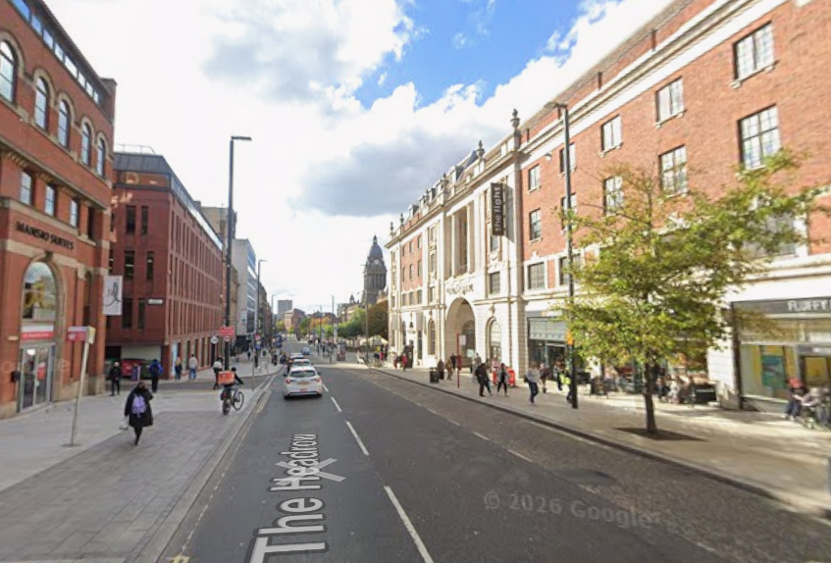
Continue straight on The Headrow until you reach the end of the road.
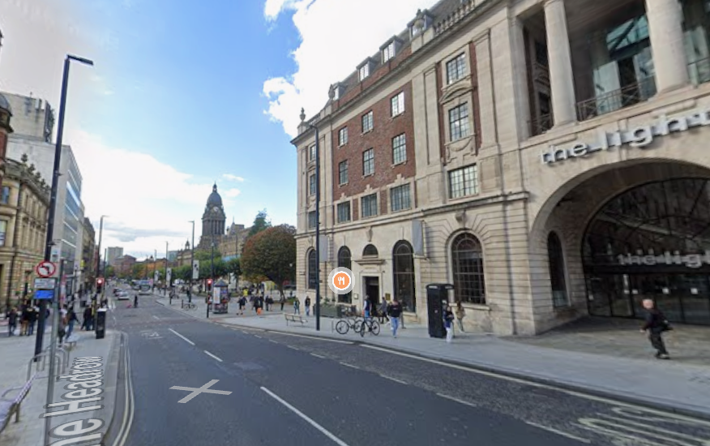
You will see ‘The Light’ shopping centre. Keep walking down the path towards ‘Browns’ restaurant.

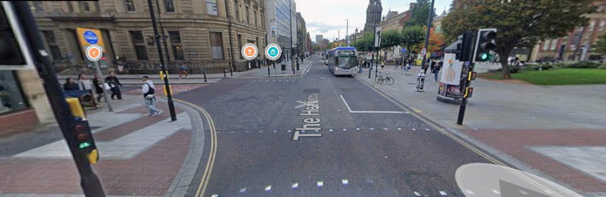
Cross safely at the crossing by Caffe Nero towards Browns restaurant. Wait for the green man.
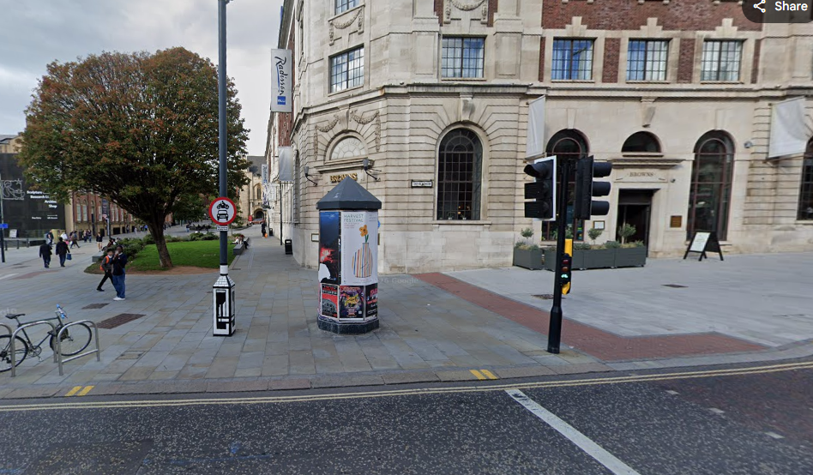
Then turn left and immediately right onto Cookridge street.

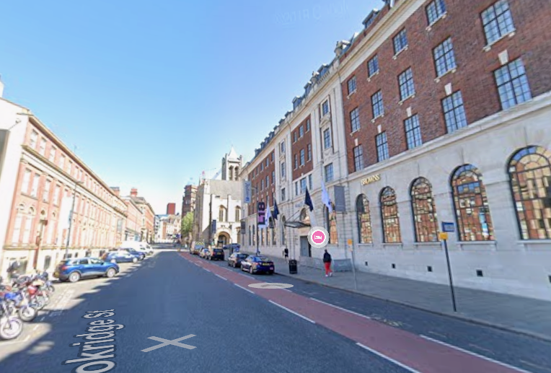
Now walk up Cookridge Street past Browns and Nation of Shopkeepers bar
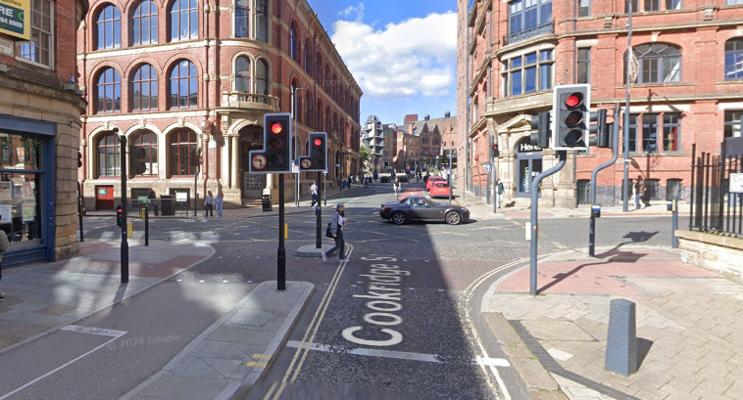
When you reach Great George Street use the crossings to continue over onto Cookridge street and head forward.

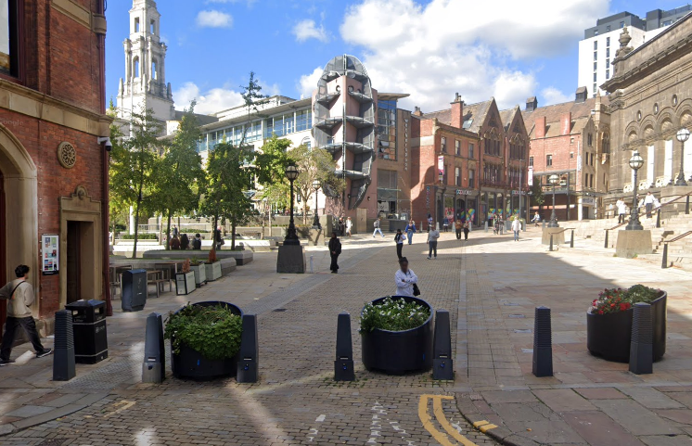
Once you see the planters continue straight (you may need to cross the road if you are on the right) until you get to a building with Pop World written on the outside.
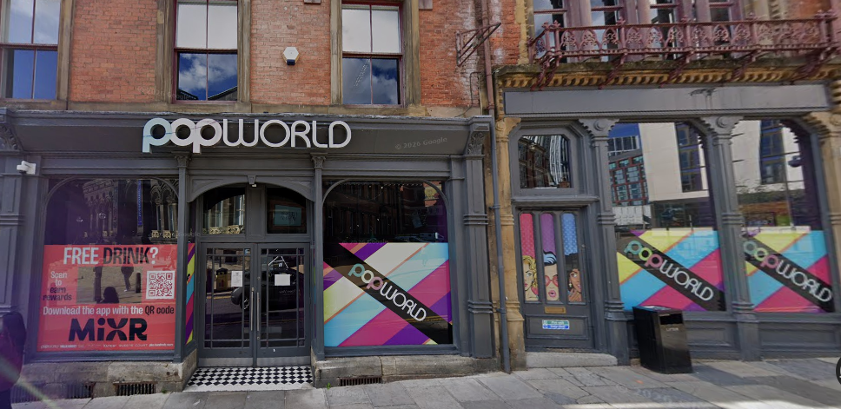
Congratulations you've made it to pop world!

