Walking Journey from
Leeds Bus station to Pub night (Griffin)
6pm on Tuesday 16th June
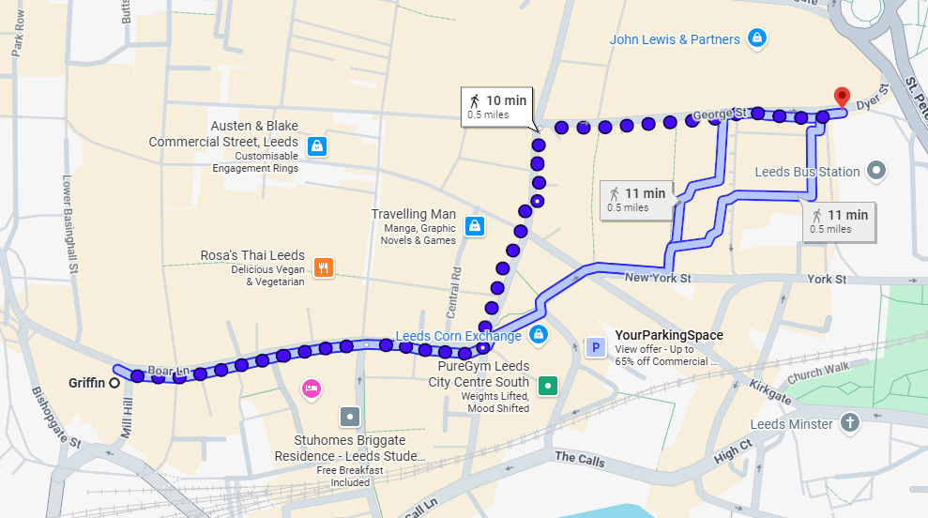
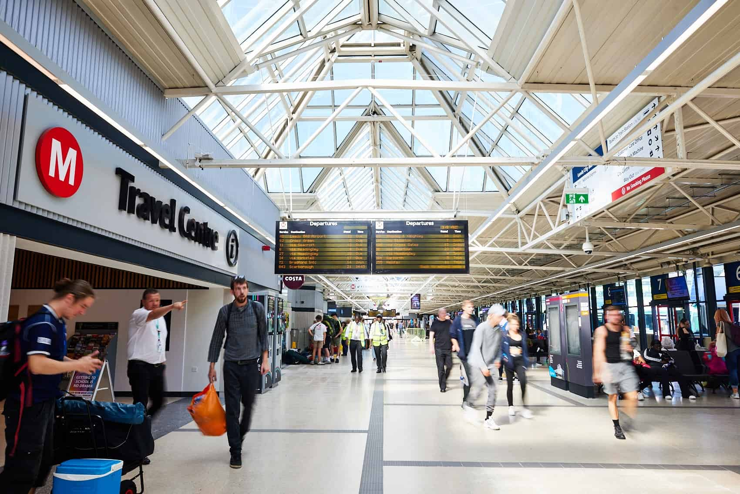
If the travel centre on your left head straight until you reach the exit!
If not turn left from the stand you were at and continue straight to the exit!
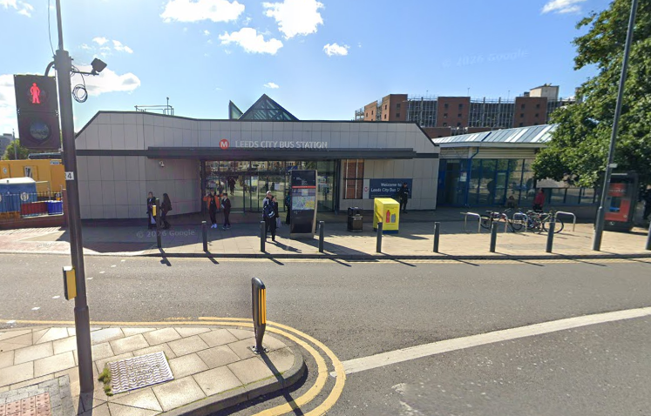
(THIS IS THE MEETING POINT! – wait for the group HERE)
At the exit Turn left and head up George Street

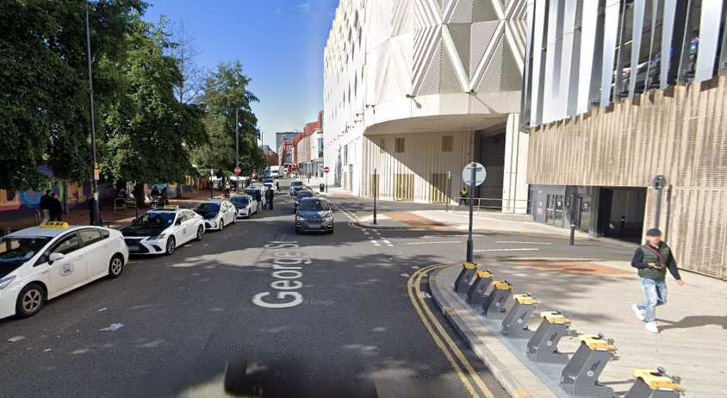
Head Up George Street until you reach the end (Vicar Lane)
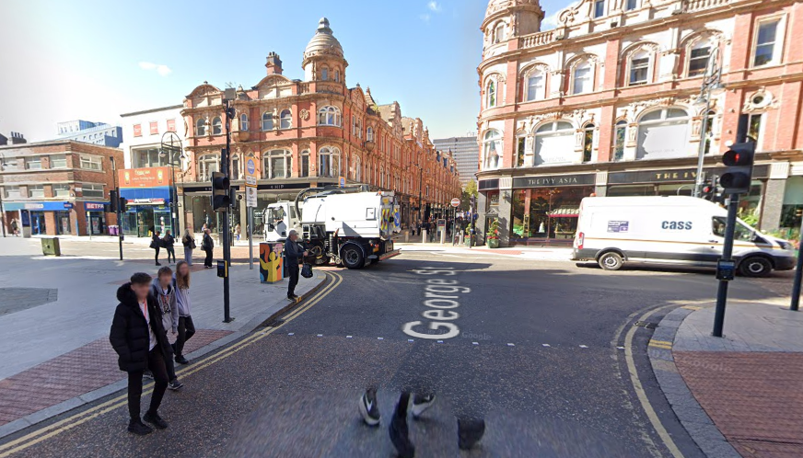
When you reach the end turn left onto Vicar Lane.

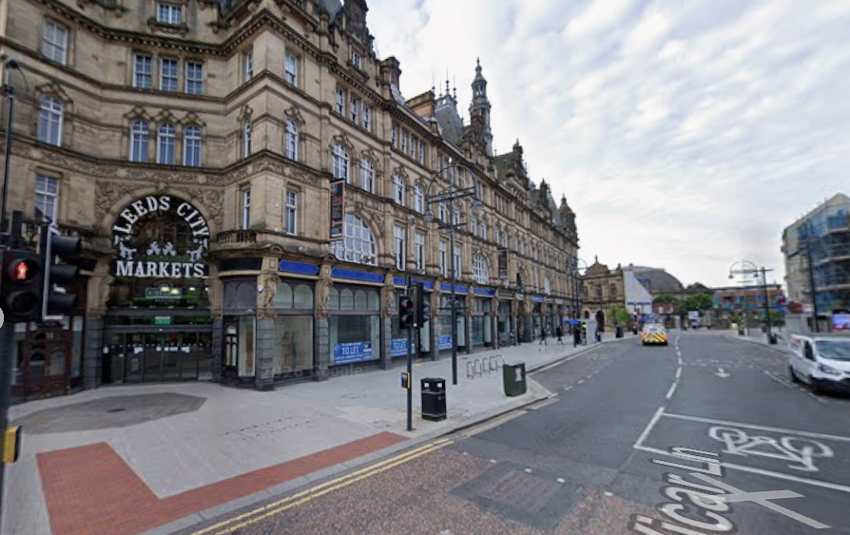
Go past Leeds city Market
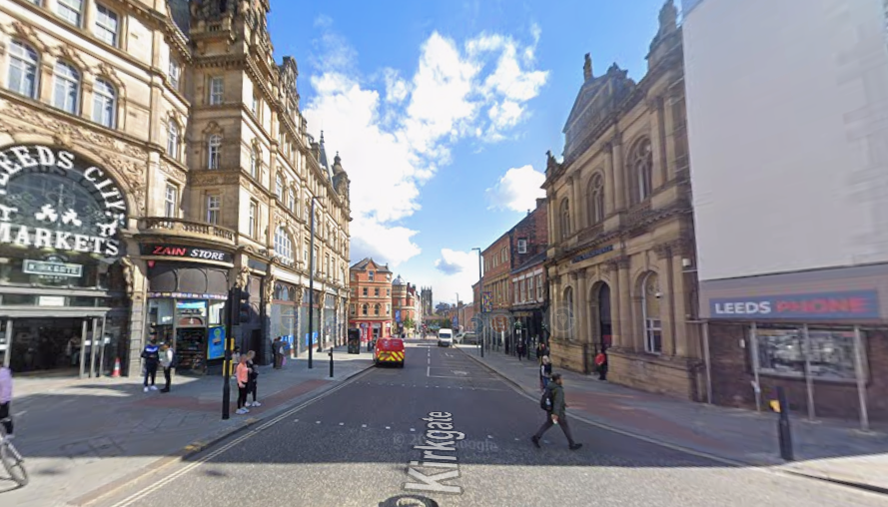
Cross The Road when green man shows, continue straight on to New Market Street.

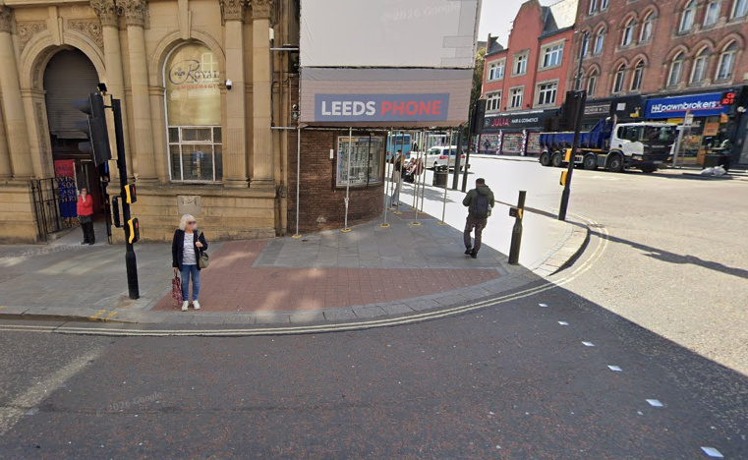
Continue straight on to New Market Street
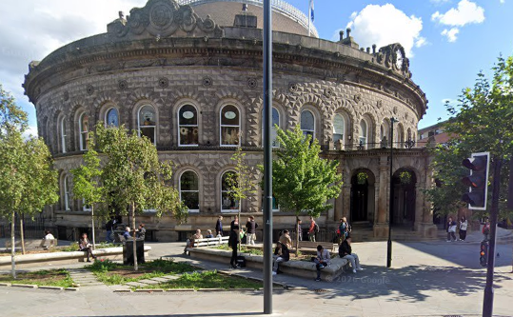
Pass the corn exchange.

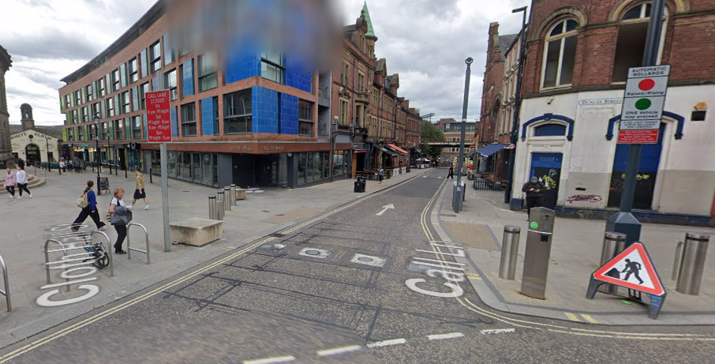
When pass the corn exchange use this crossing to head right on to Duncan Street and continue forward.
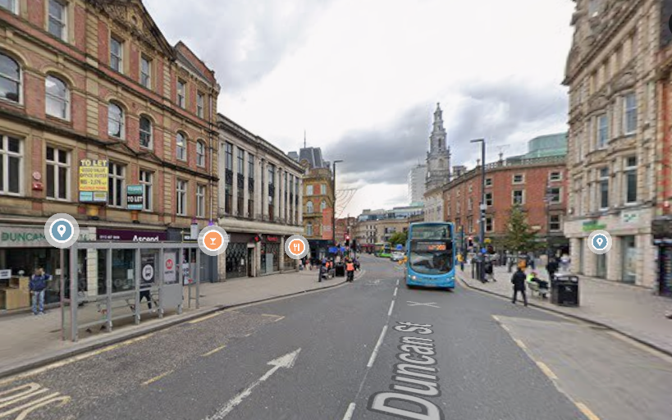
Continue to the crossing.

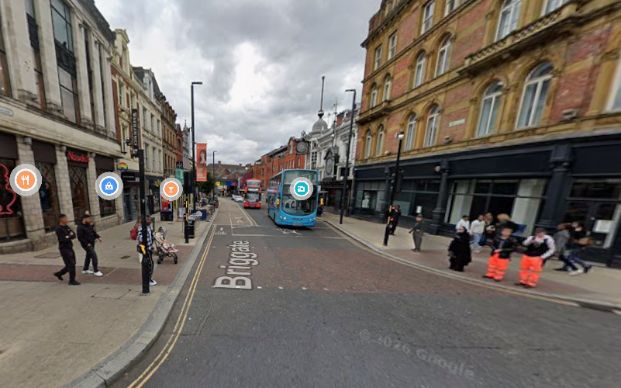
Wait for the green man and safely cross the road.
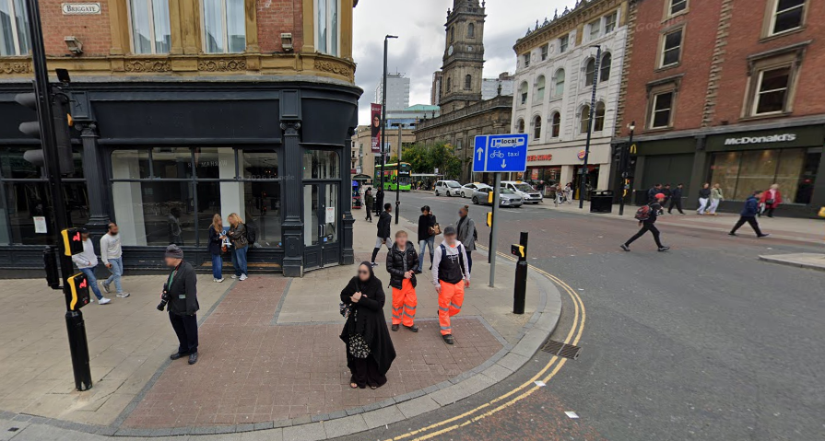
Continue straight onto Boar Lane

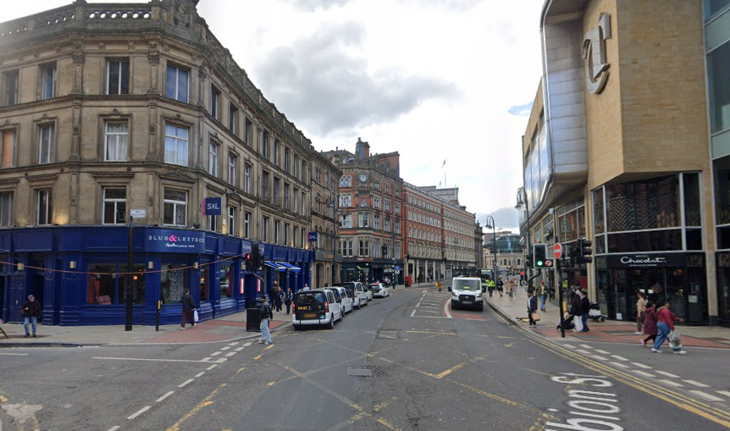
When you get to the Junction with New Station & Albion Street cross over new station street when green man and continue straight onto Boar Lane
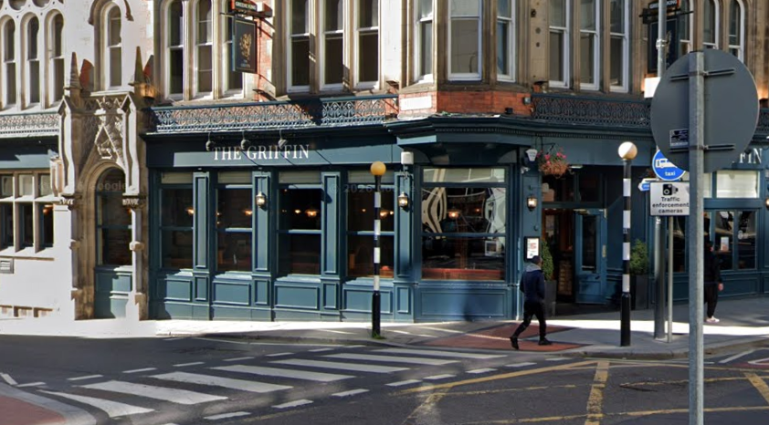
Once you Get to the Zebra Crossing use it to cross the road and then the griffin should be right in front of you!

