Council Chambers Takeover –
Journey from Civic Hall to Kirkgate Market 12:40pm Tuesday 16th June
This is the route from Civic Hall to Kirkgate market on public transport, this has 5 minutes of walking. We will get the number 56 bus from outside Subway (Merrion C stop out of use) then we will get off at the bus station and walk to the food court at the Market.
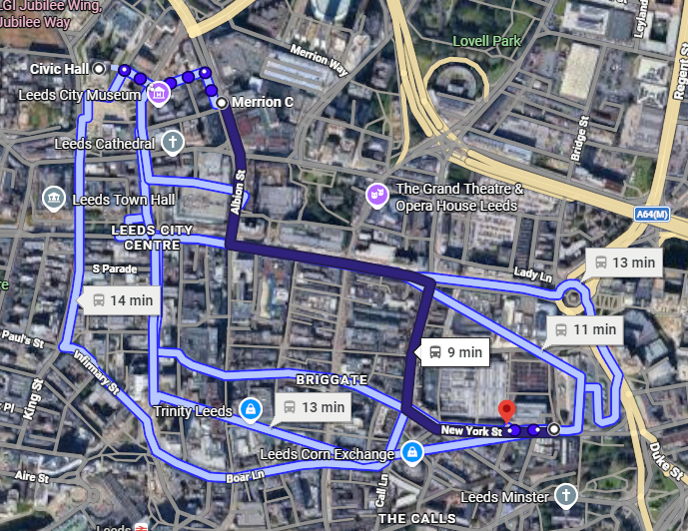
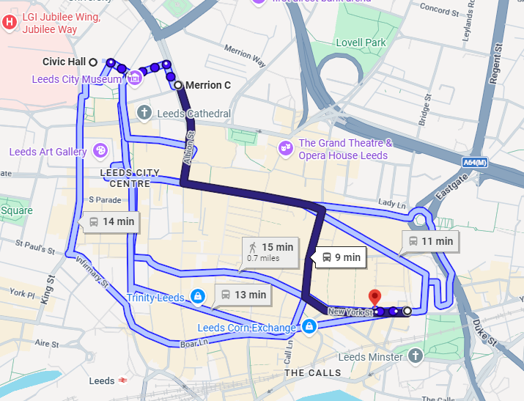
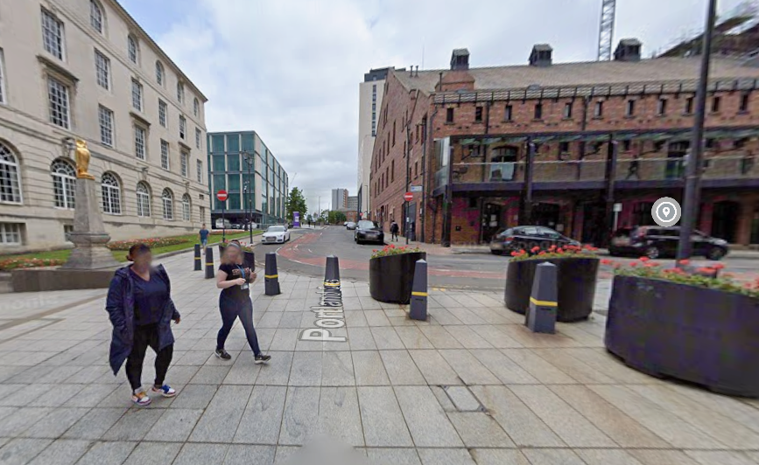
Coming out of the Council Chambers, we will wait here and set off at 12:45pm, we will walk straight out onto Portland gate, towards pop world.

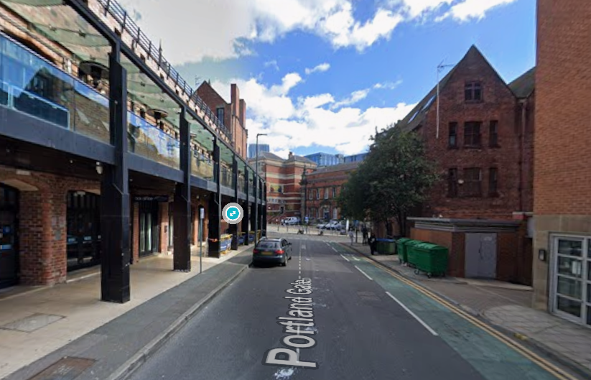
Head up Portland gate towards Pop World

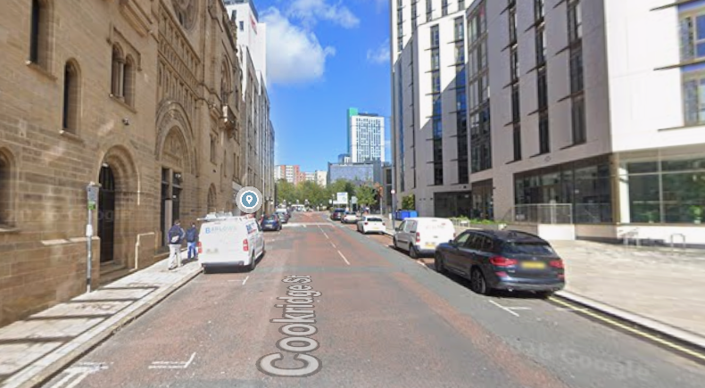
Walk up Cookridge street

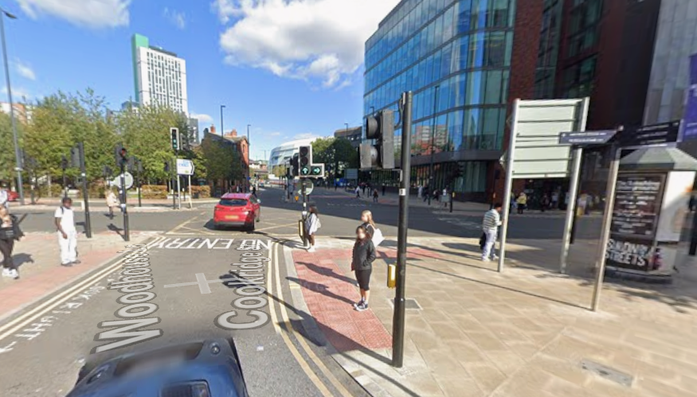
Turn left onto Woodhouse lane toward Merrion Centre

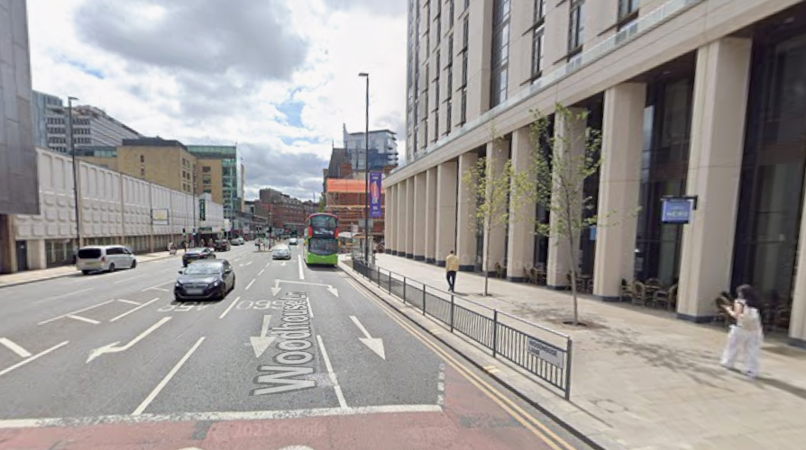
Walk towards Merrion centre

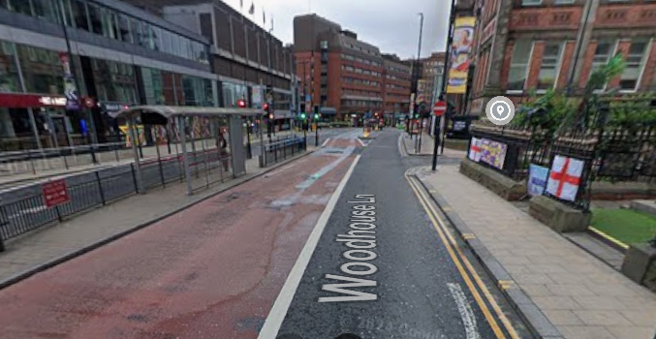
You will now be approaching a crossing and we will look to cross over

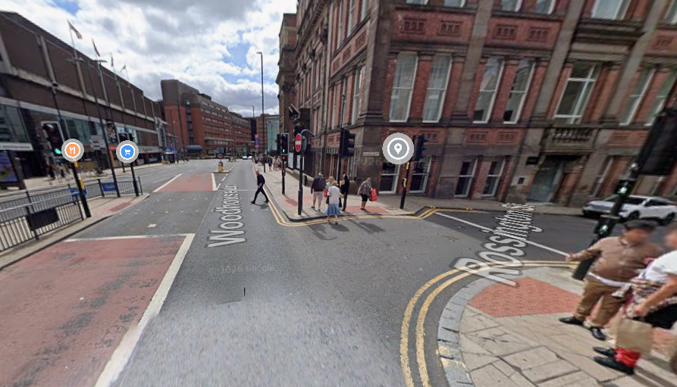
We will safely cross over Rossington Street.

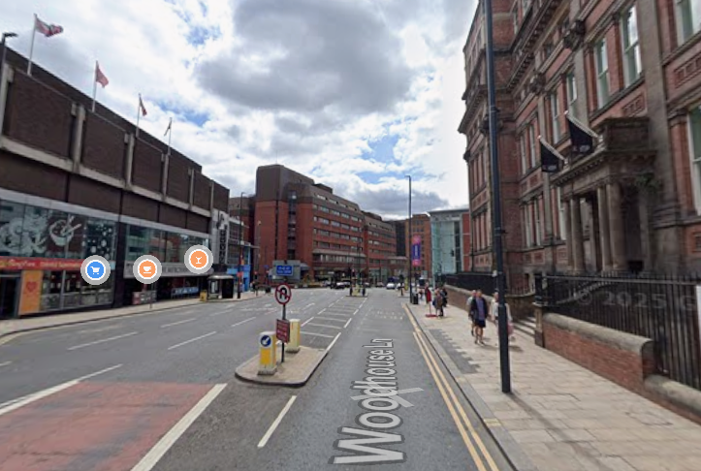
Continue down Woodhouse lane until the next crossing
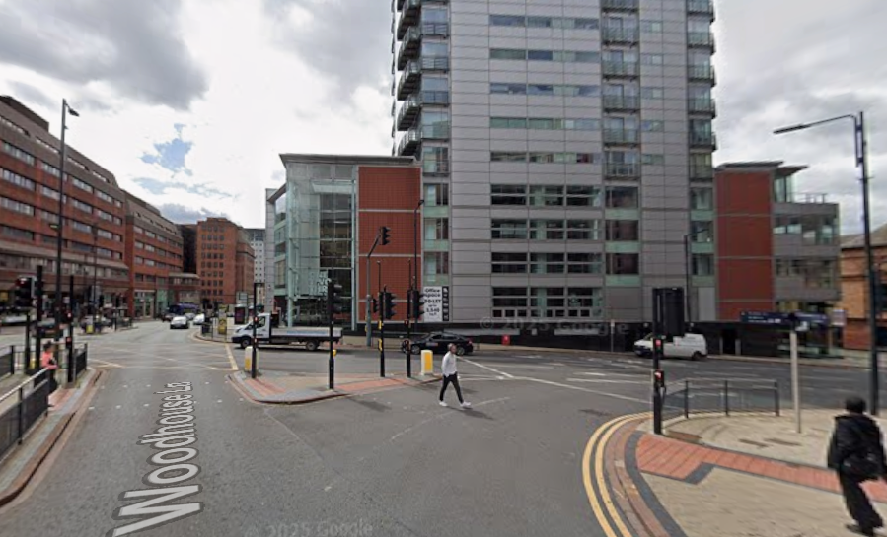
This is the crossing, there is two sets of traffic lights, cross safely and wait for the green man at both crossings.
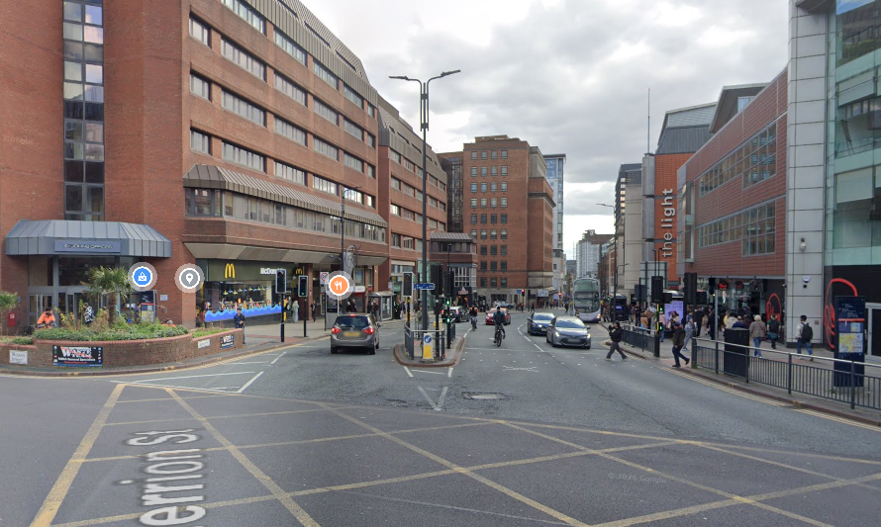
Same again, we will cross over towards macdonalds, crossing safely into the middle, and waiting again for the green man on the other side
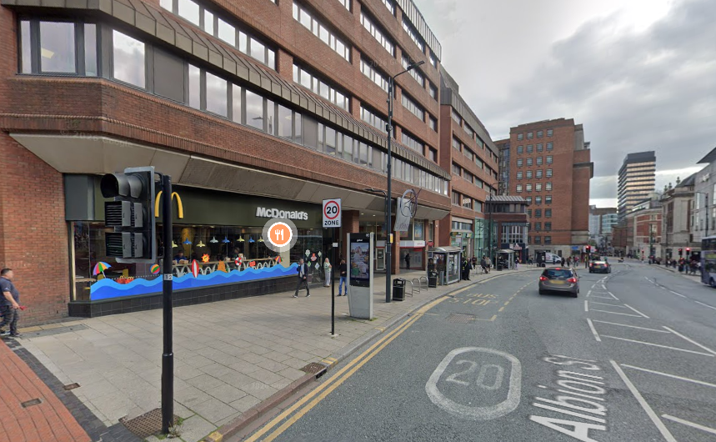
Walk down towards Subway
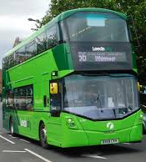
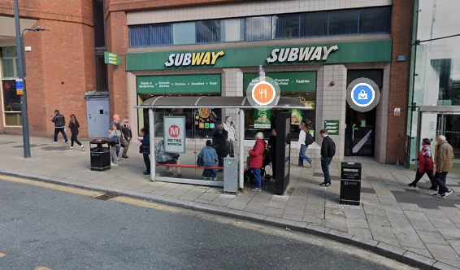
This is your bus stop, we will get the bus number 56.
We will get off the bus at the bus station (the 2nd stop)

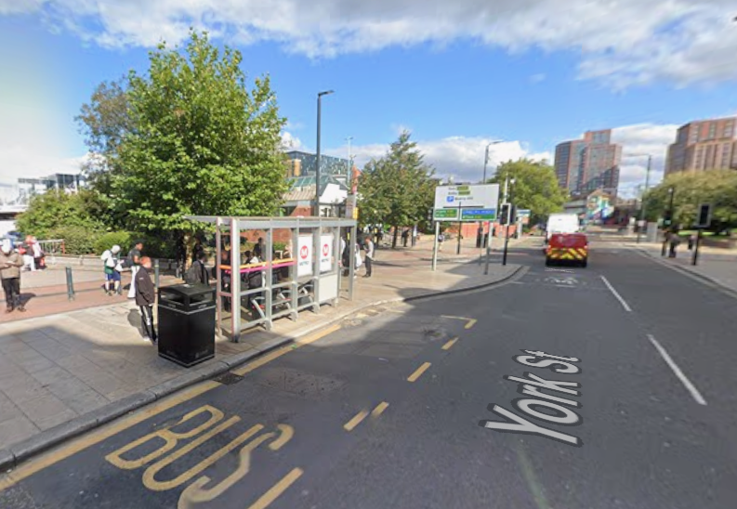
This is your stop, just before the bus station. Get off here.

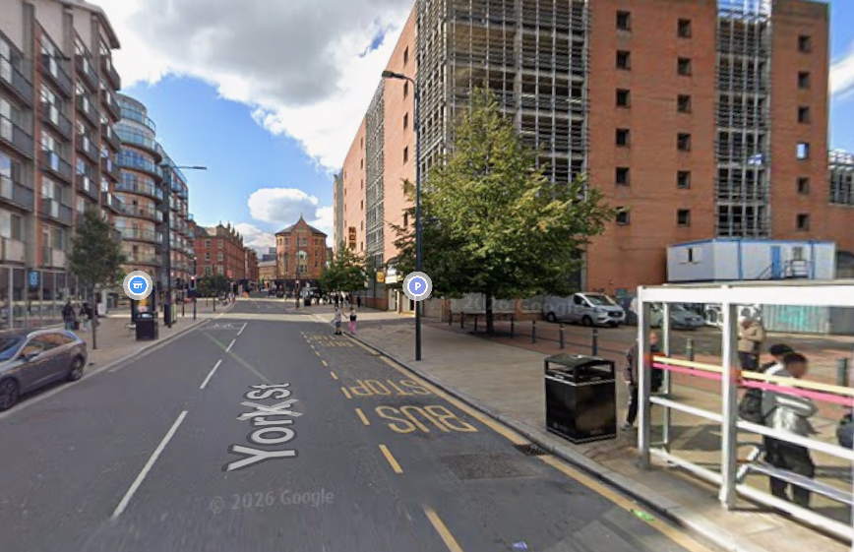
Walk back up York Street towards the market

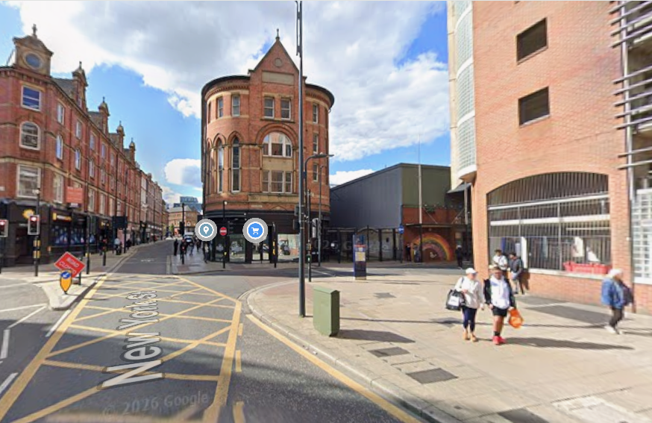
When you get to the crossing, turn left towards the market.

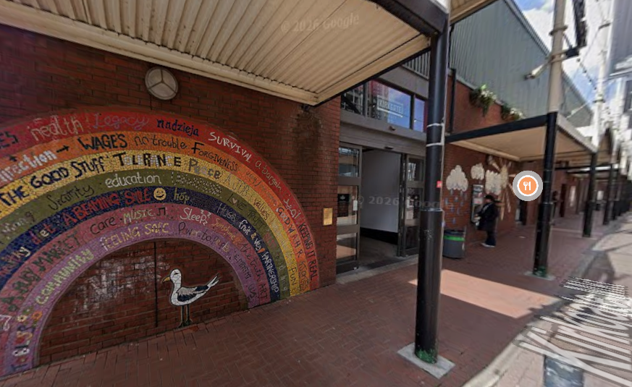
This is the door to the food market, go inside, to the top right.

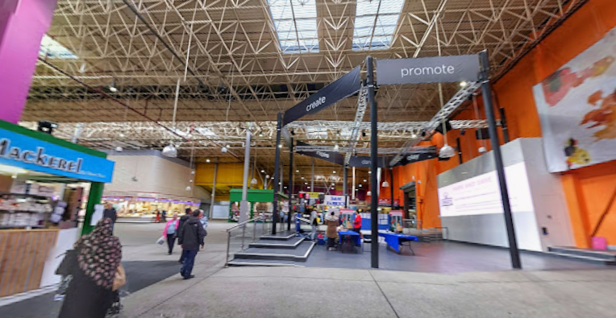
This is the seating area we will be meeting in.

