Council Chambers Takeover -
Journey from Unity Business Centre to Leeds Civic Hall on Millenium Square.
8:45am on Tuesday 16th June
Start from Advonet at Unity Business Centre. This journey should take about 20 minutes if the buses are on time.

You can get the 7A bus to the Headrow (A) and get off the opposite side of the road to the Light shopping centre.
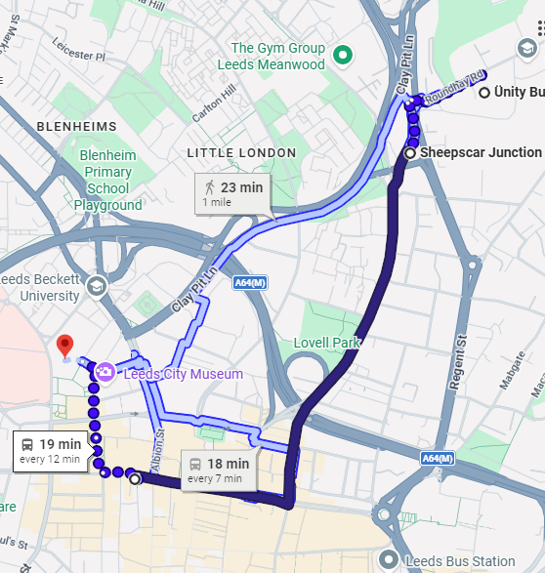
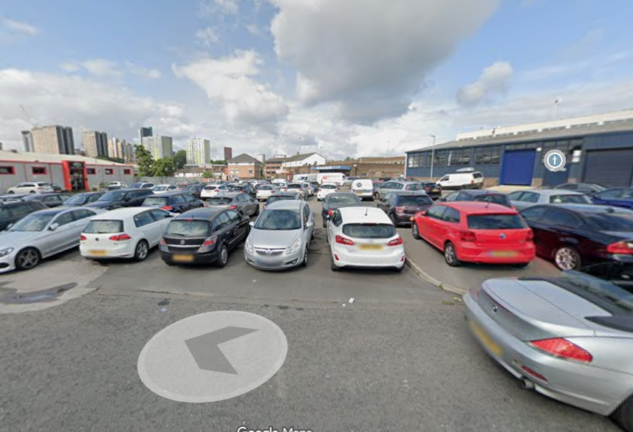
Walk out of the Advonet building and turn left.
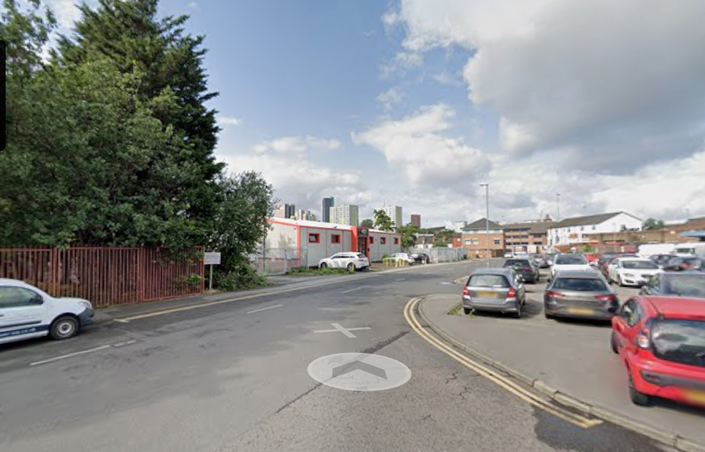
Cross over safely over the road in front, then to the left.
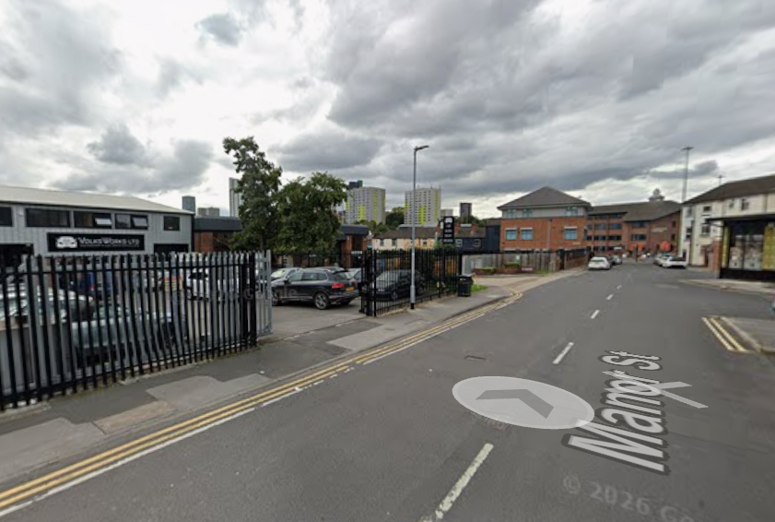
Now walk down the road passed the Volkswagen repair centre, being careful of cars coming out of the car parks.

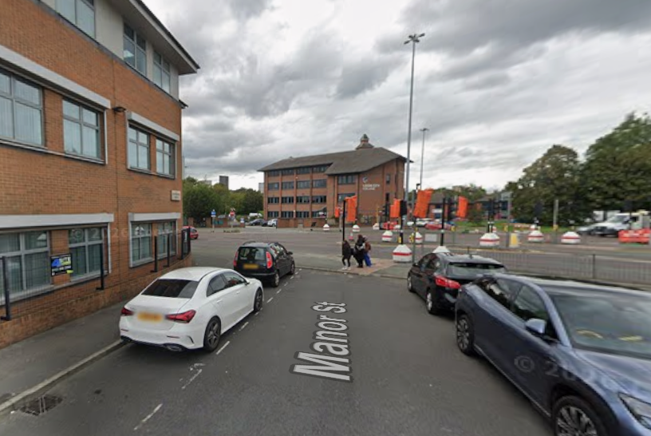
Turn left at the end of the street.
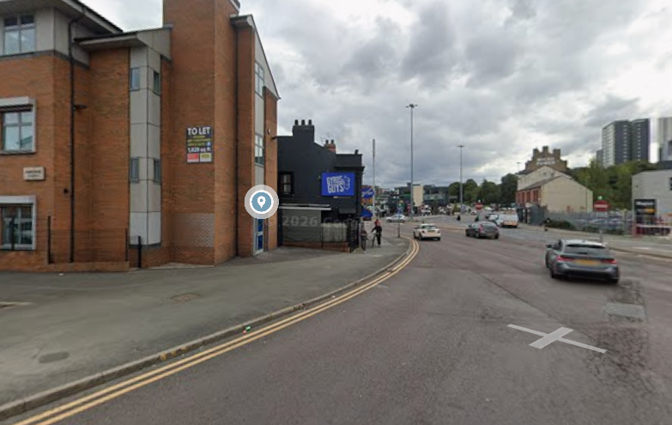
After turning left, go past the sign ‘gyros guys’, head to the crossing.

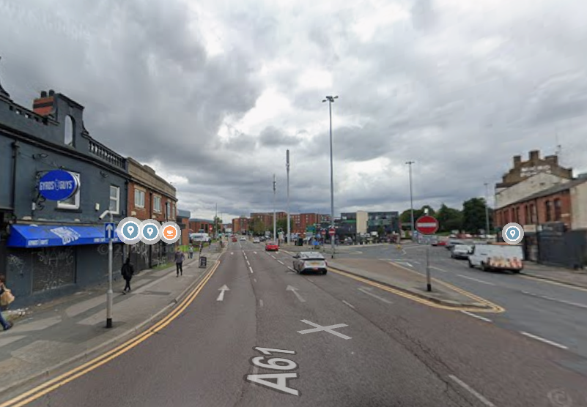
Head straight until ‘Howdens’ is on your left and the crossing is on your right.
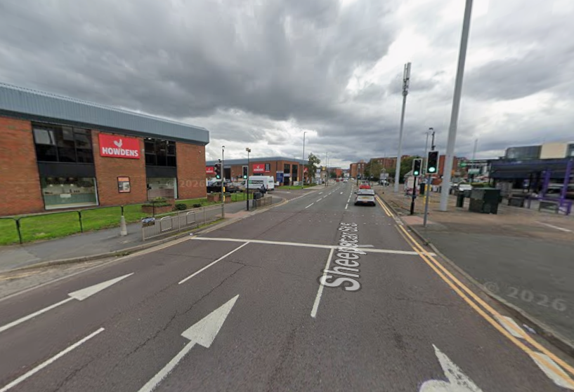
This is the crossing you will use to cross over the road towards the Car Wash where you will get the bus from at the bus stop. Wait for the green man.

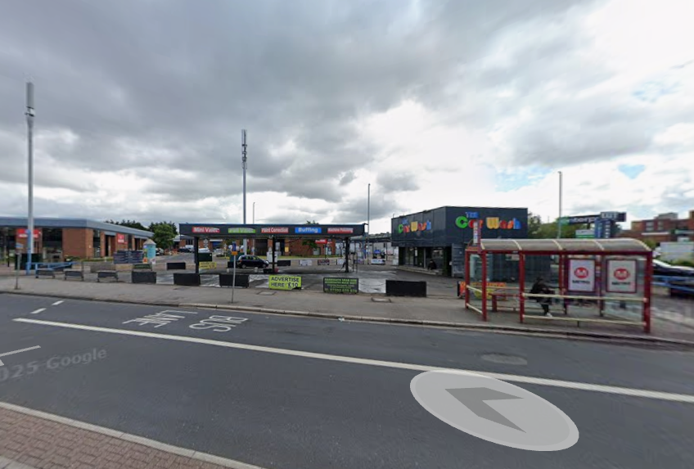
Cross over the road safely at the crossing. You can get the number 7A bus from Sheepscar junction by the car wash. Ride 4 stops on this bus.
You can get the 7A bus to the Headrow (A) and get off the opposite side of the road to the Light shopping centre.
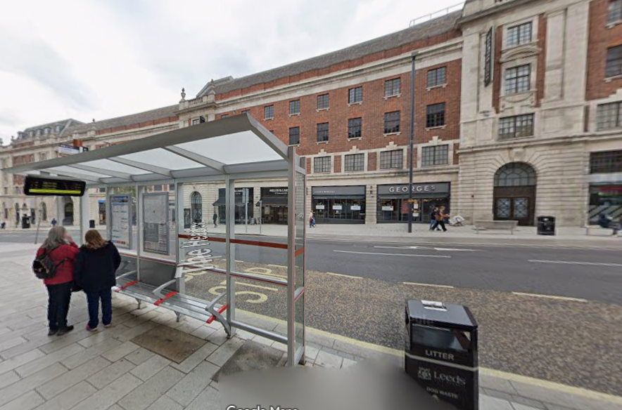
Get off the bus here at bus stop (Headrow A) opposite The Light shopping centre. Don’t forget to press the bell!

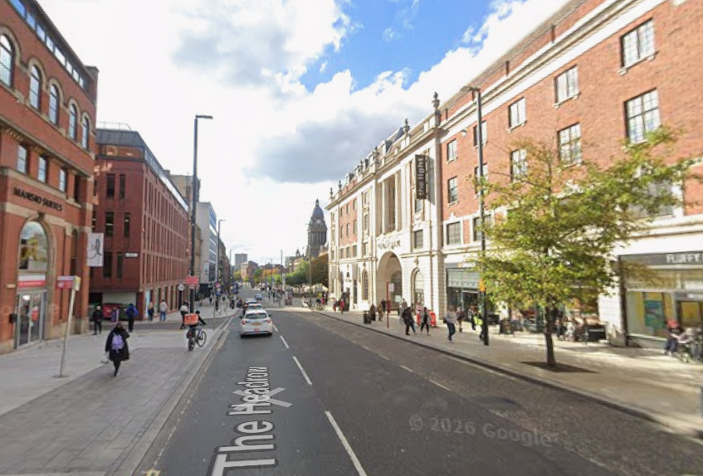
Walk down the road passed the NHS blood donor centre.
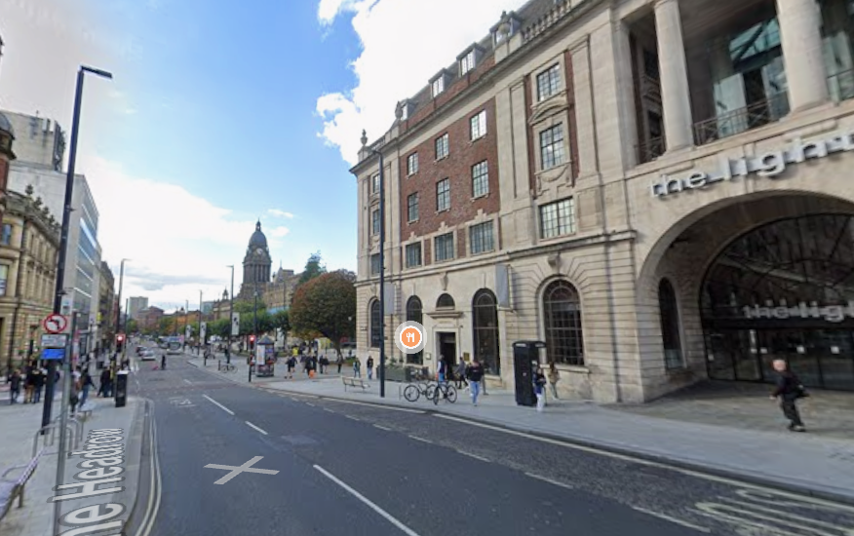
You will see ‘The Light’ shopping centre. Keep walking down the path towards ‘Browns’ restaurant.

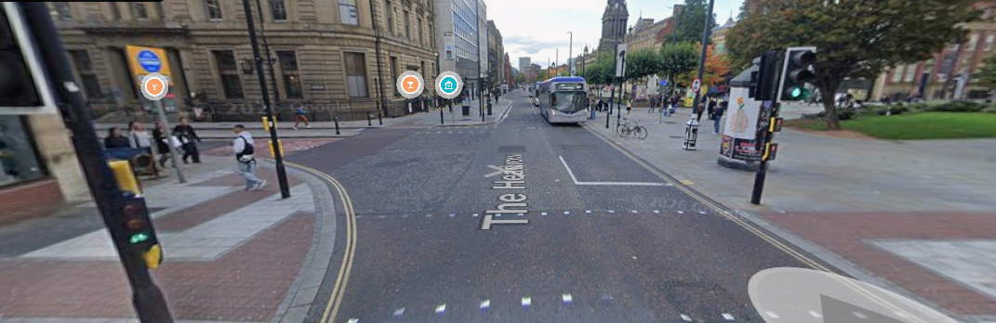
Cross safely at the crossing by Caffe Nero towards Browns restaurant. There are traffic lights here.

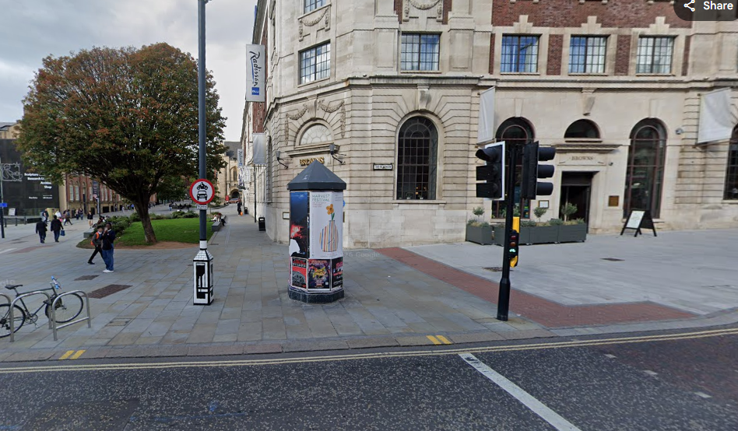
Then turn left and immediately right onto Cookridge street.

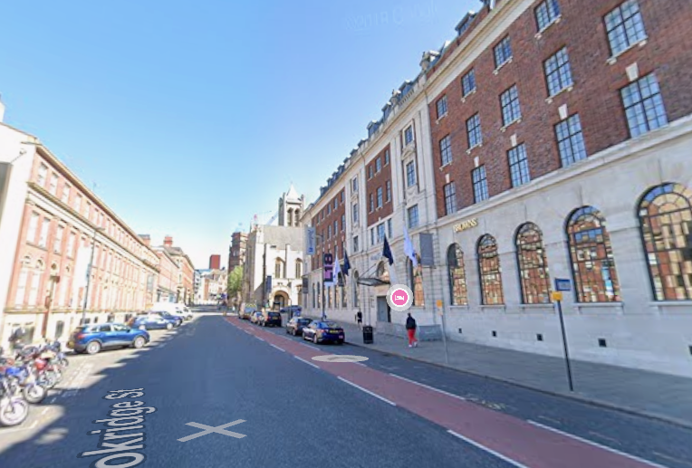
Now walk up Cookridge Street past Browns and Nation of Shopkeepers bar.

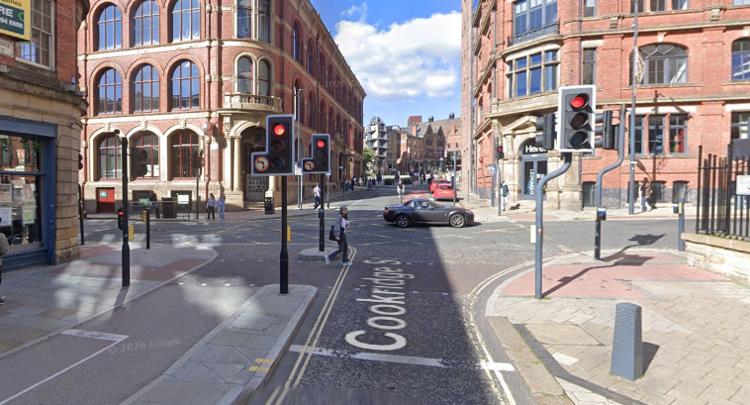
When you reach Great George Street use the crossings to continue over onto Cookridge street and head forward.

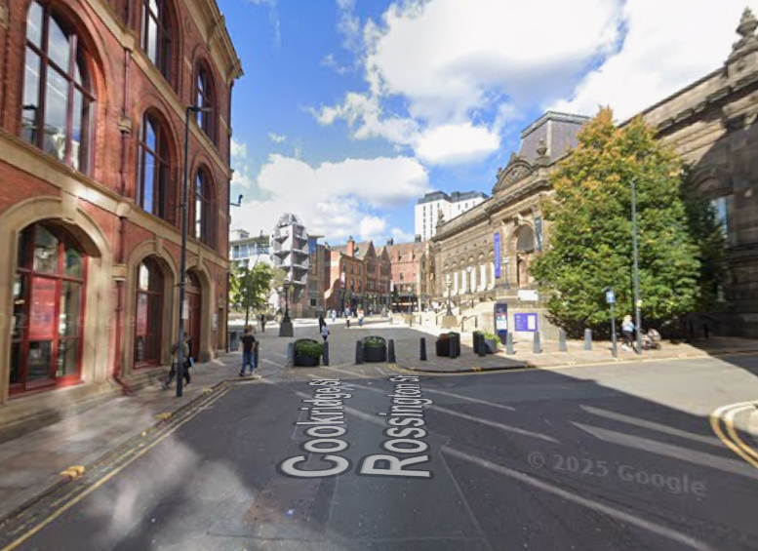
Walk straight onto millennium square and keep walking forward towards Popworld.
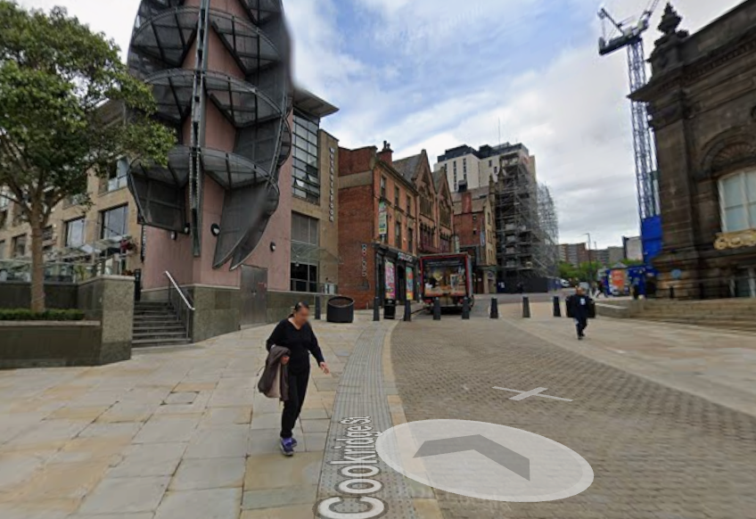
Go past Millenium square and the city museum

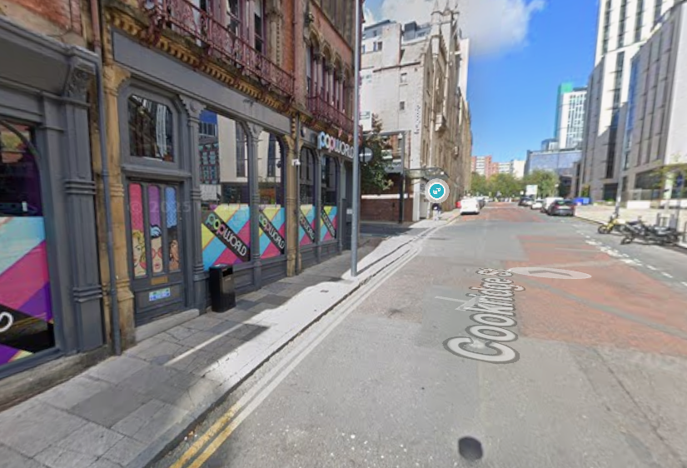
Go passed Popworld and turn left.
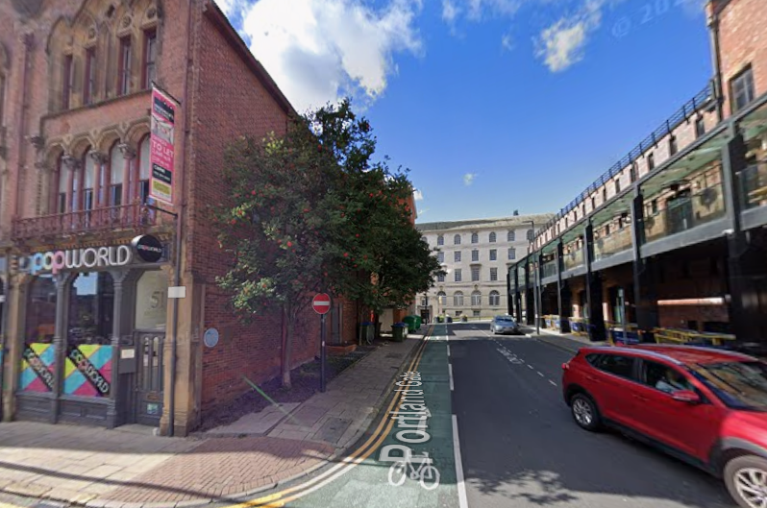
Walk down Portland gate all the way.

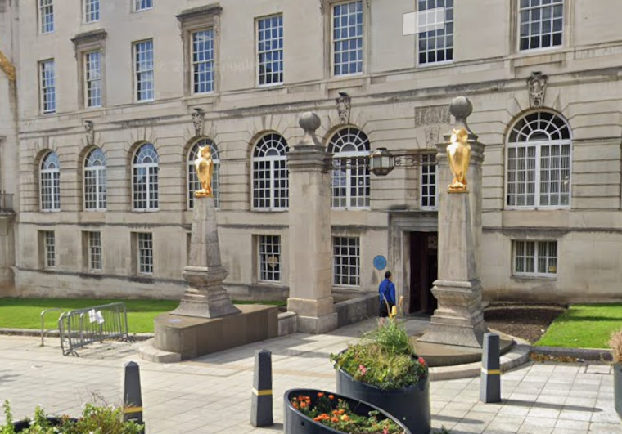
Go in the entrance of the building past the 2 golden owls.
Congratulations! You have made it to the Council Chambers!

